ASSIGNMENT NO. 4

**UML DIAGRAMS**

a) UML Diagrams or other necessities using appropriate tools:

UML Diagrams consists of the following diagrams:

1. Activity diagram

2. Component diagram

3. Sequence diagram

4. Deployment diagram

5. Interaction diagram

6. Statechart diagram

7. Use-case specification

1. Activity diagram 2. Component diagram

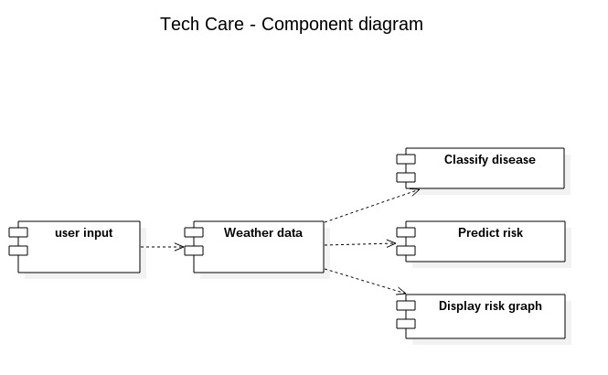

3. Sequence diagram

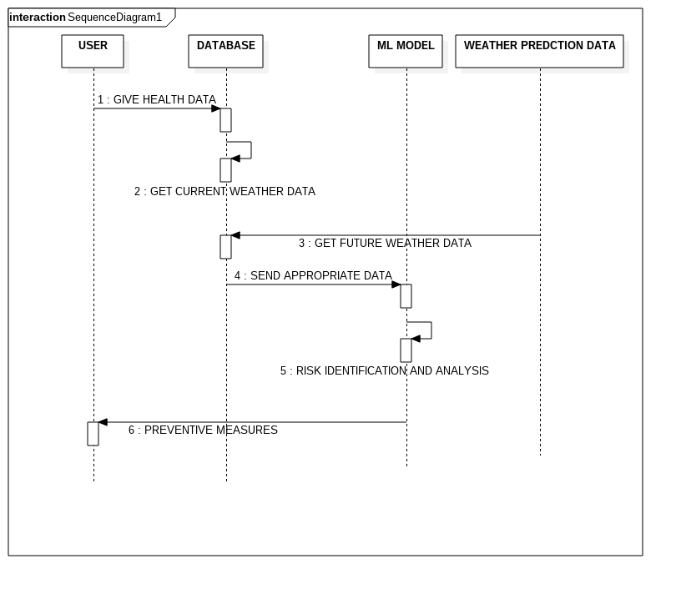

4. Deployment diagram

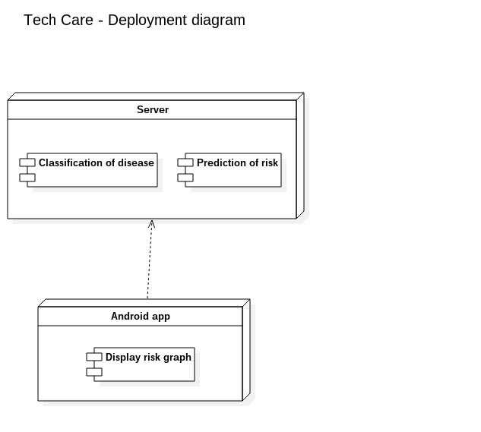

5. Interaction diagram

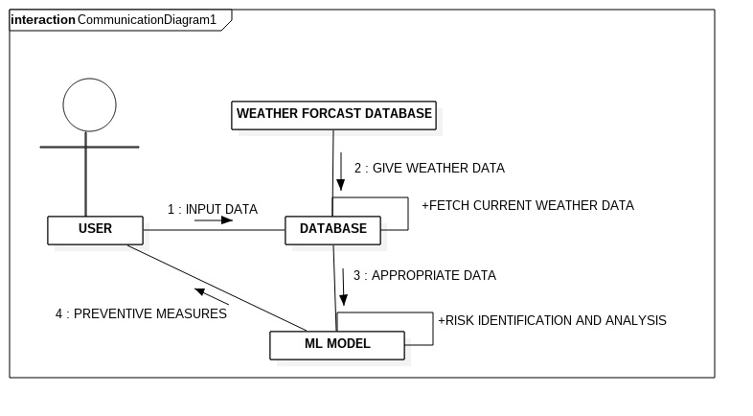

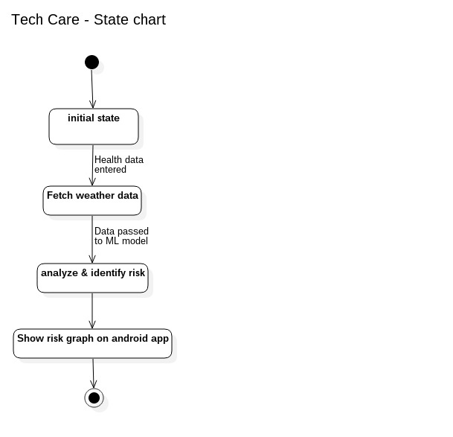6.Statechart diagram

7. Use case diagram

